Tasks on Terraform-06

1) Watch terraform-06 video.

Completed Watching video.

2) Execute the script shown in video.
Terraform Modules:
=================
Modules is a collection of configuration files in a directory.

For example if we want to create two ec2 for different environemnts
then i can create a directory for aws-instance configuration.
Example:
=======
resource "aws_instance" "webserver" {
ami = var.ami
instance_type = "t2.micro"
}

now let me create a directory for dev under root directory.

example: for dev and prod
module "dev-webserver" {
source = "../aws_instance"
ami = "ami-09e6f87a47903347c"
}

Create directory aws_instance with main.tf and variables.tf
Create one dev and one prod directory in that main.tf file and add templates accordingly.

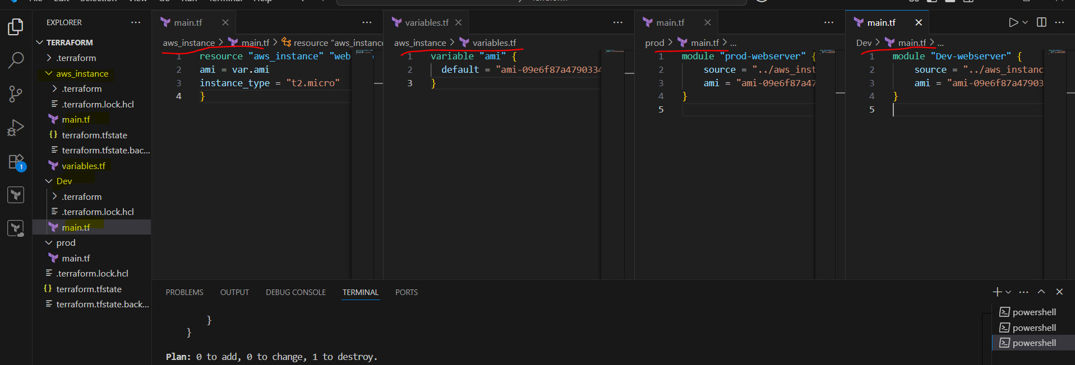

Applying in the root module:

terraform init
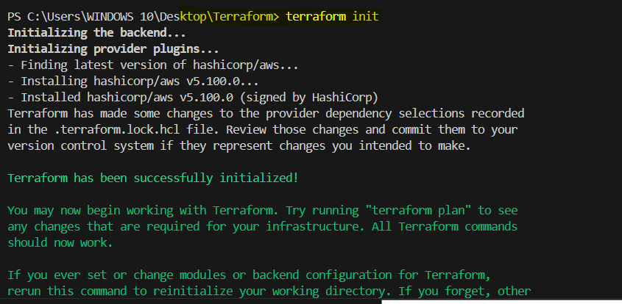

terraform apply
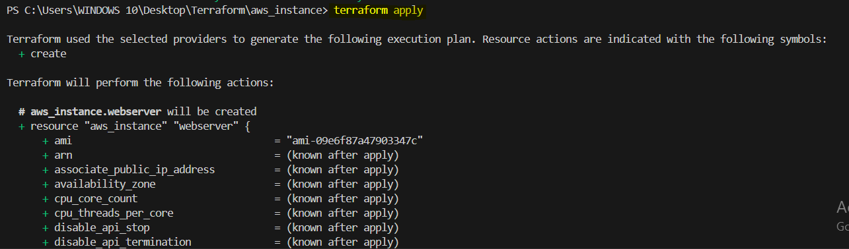
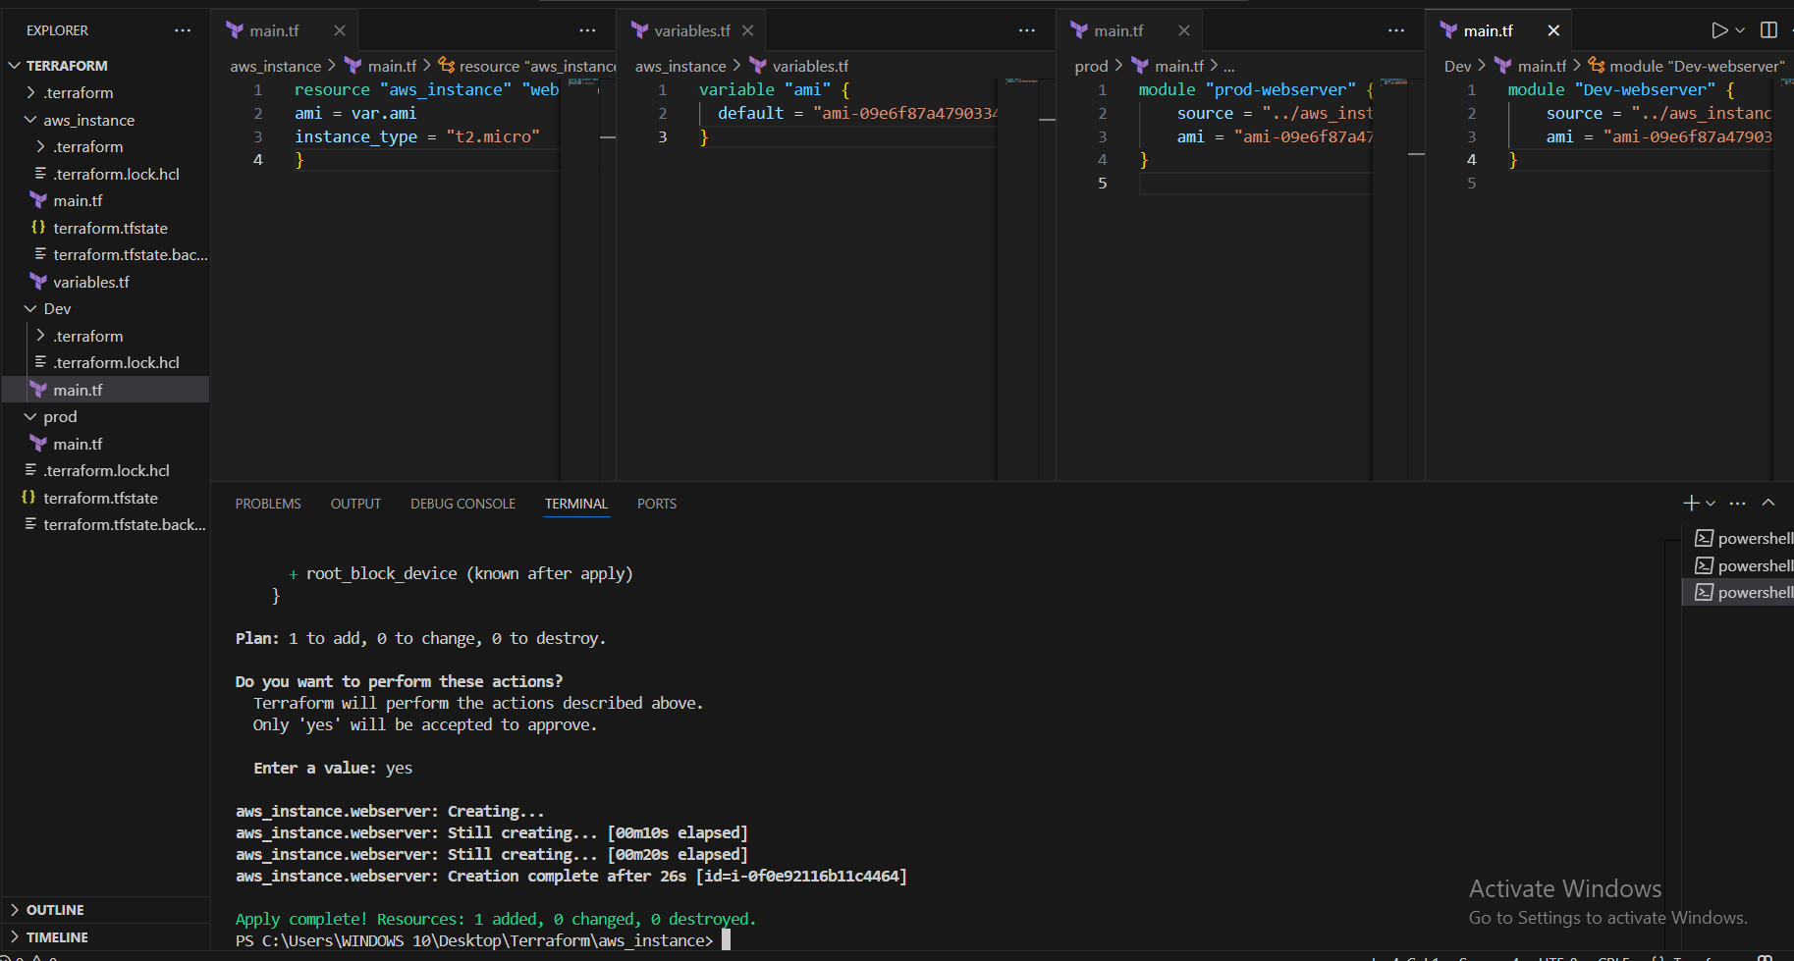

Verifying at console.
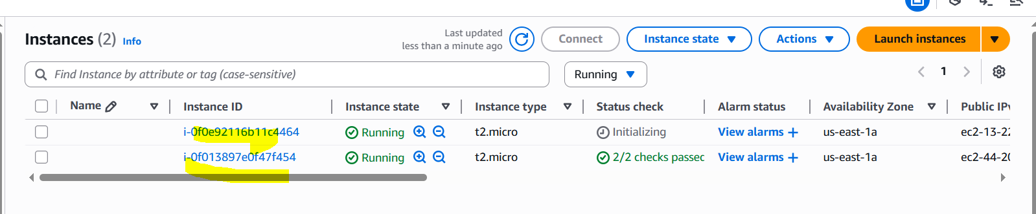

Terraform workspaces:
====================
Workspace can be used if we have multiple project/environments using the same configuration.

Workspace commands:
==================
terraform workspace new projectA --> to create a workspace names projectA
terraform workspace list --> to list the workspaces available
terraform workspace select projectA --> to swtich to specific workspace

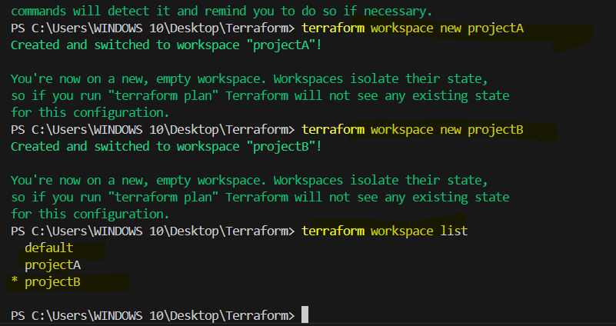

Example:
main.tf:
=======
resource "aws_instance" "webserver"
ami = var.ami
instance_type = "t2.micro"
}
variable.tf:
===========
variable "ami" {
type = map
default = {
"ProjectA" = "ami-02f3f602d23f1659d"
"ProjectB" = "ami-02f3f602d23f1659d"
}
}

when using workspaces state files will be created in the main directory
under a folder "terraform.tfstate.d"

terraform apply in both the workspaces.
projectA:
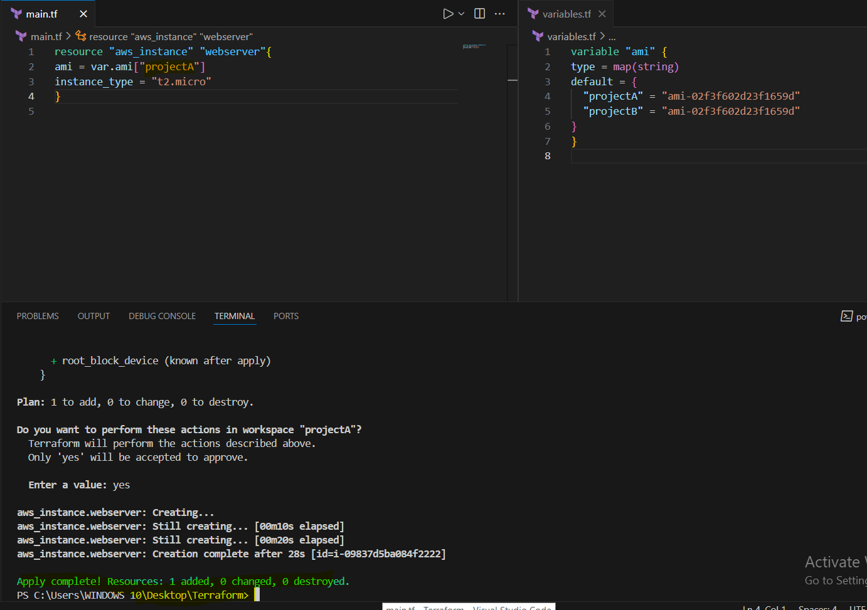

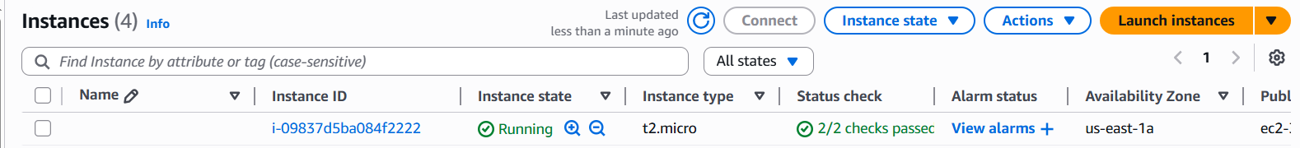

projectB:
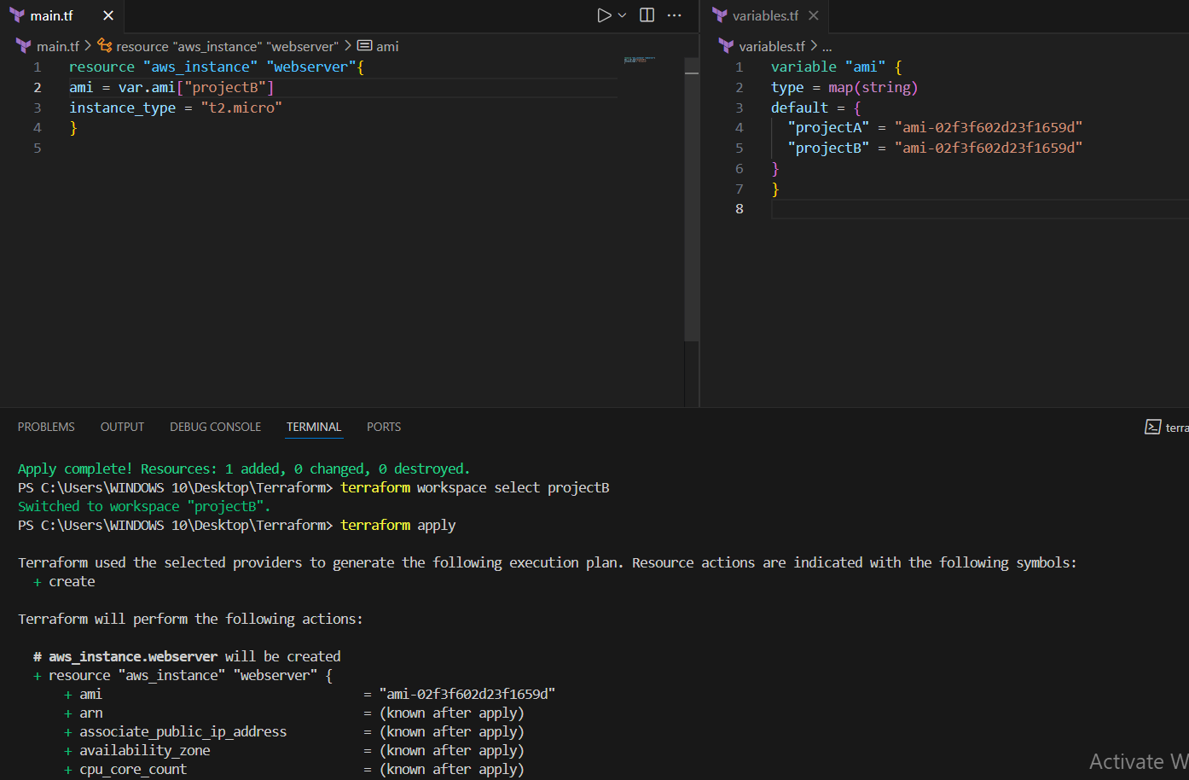

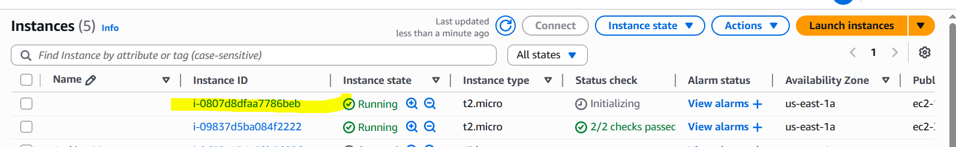

3) Provision ec2,s3 and vpc using Terraform modules.

Module directory format:

terraform-project/
├── aws_infra/
│ ├── main.tf
│ └── variables.tf
├── dev/
│ └── main.tf
├── prod/
│ └── main.tf

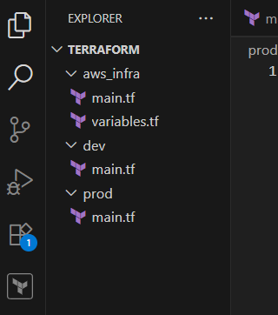

Templates to be added for modules.

├── aws_infra/
│ ├── main.tf
resource "aws_vpc" "mubeen-tf-vpc" {
cidr_block = var.vpc_cidr
tags = {
Name = "mubeen-tf-vpc-${var.env}"
}
}

resource "aws_subnet" "mubeen-tf-subnet" {
vpc_id = aws_vpc.mubeen-tf-vpc.id
cidr_block = var.subnet_cidr
availability_zone = var.az
map_public_ip_on_launch = true

tags = {
Name = "mubeen-tf-subnet-${var.env}"
}
}

resource "aws_instance" "mubeen-tf-ec2" {
ami = var.ami
instance_type = var.instance_type
subnet_id = aws_subnet.mubeen-tf-subnet.id

tags = {
Name = "mubeen-tf-ec2-${var.env}"
}
}

resource "aws_s3_bucket" "mubeen-tf-s3" {
bucket = "mubeen-tf-s3-${var.env}-${var.unique_id}"
tags = {
Name = "mubeen-tf-s3-${var.env}"
}
}

│ └── variables.tf
variable "env" {}
variable "ami" {}
variable "instance_type" {}
variable "vpc_cidr" {}
variable "subnet_cidr" {}
variable "az" {}
variable "unique_id" {}

├── dev/
│ └── main.tf
provider "aws" {
region = "us-east-1"
}

module "mubeen_dev_infra" {
source = "../aws_infra"
env = "dev"
ami = "ami-053b0d53c279acc90"
instance_type = "t2.micro"
vpc_cidr = "10.0.0.0/16"
subnet_cidr = "10.0.1.0/24"
az = "us-east-1a"
unique_id = "123dev"
}

├── prod/
│ └── main.tf
provider "aws" {
region = "us-east-1"
}

module "mubeen_prod_infra" {
source = "../aws_infra"
env = "prod"
ami = "ami-053b0d53c279acc90"
instance_type = "t2.micro"
vpc_cidr = "10.1.0.0/16"
subnet_cidr = "10.1.1.0/24"
az = "us-east-1b"
unique_id = "456prod"
}

Templates in the module files accordingly.

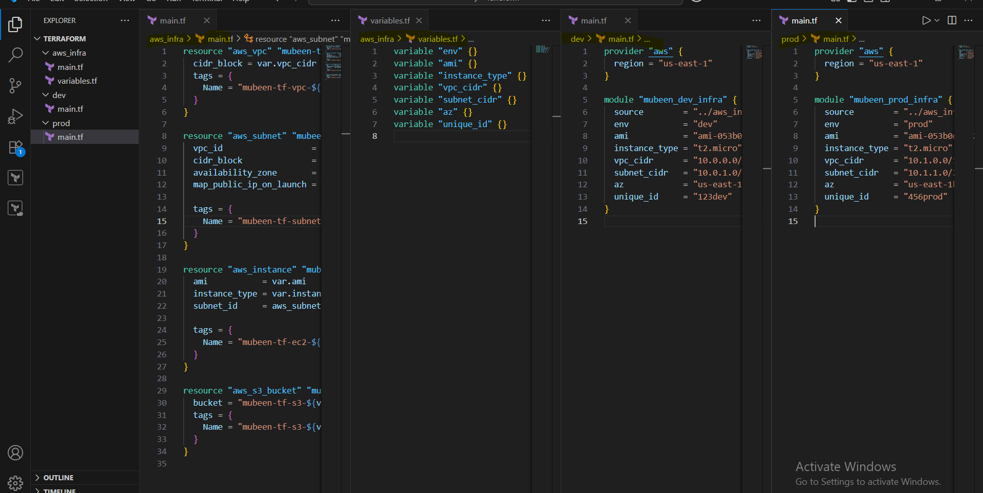

Run command terraform init in all three main.tf files similarly.
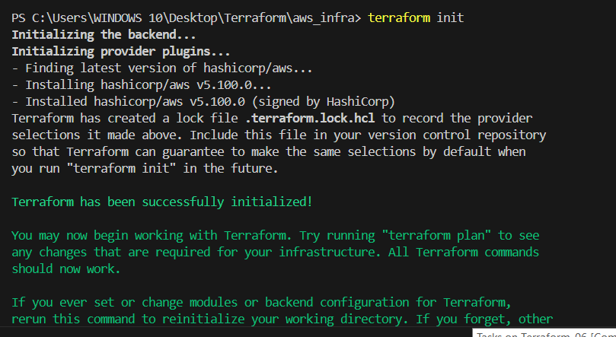

Run command terraform apply in dev and prod main.tf.
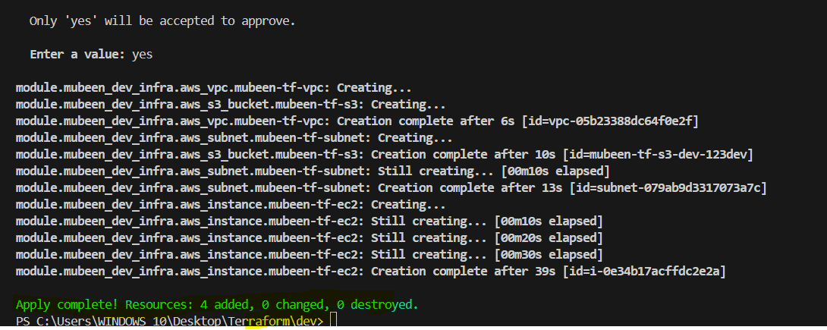

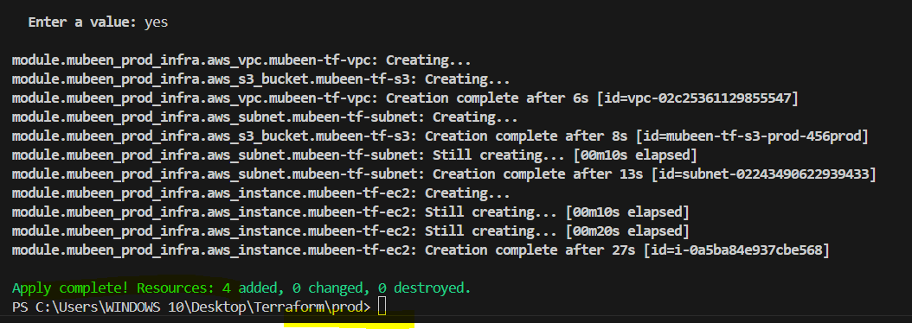
Verifying the resources on AWS console.

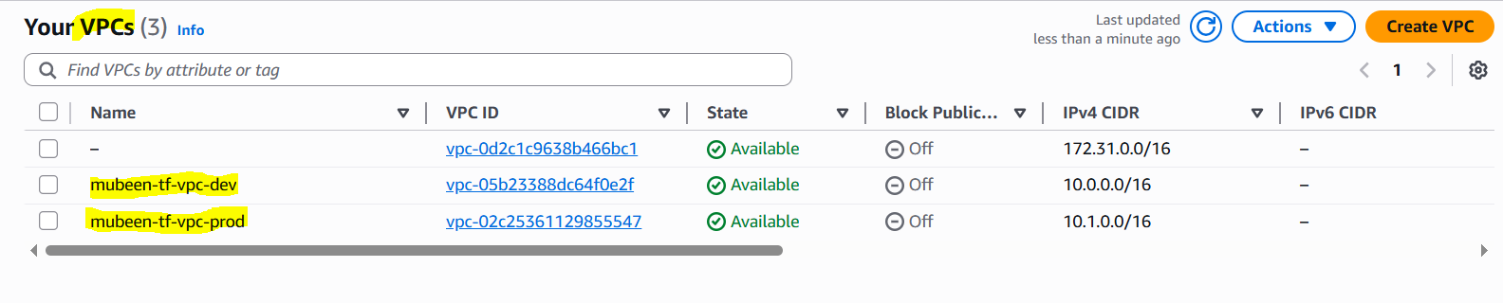

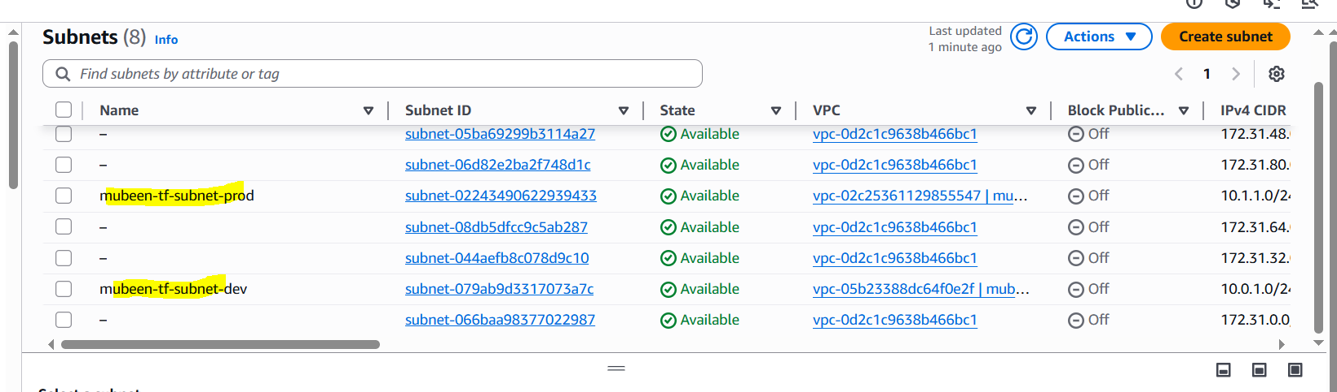

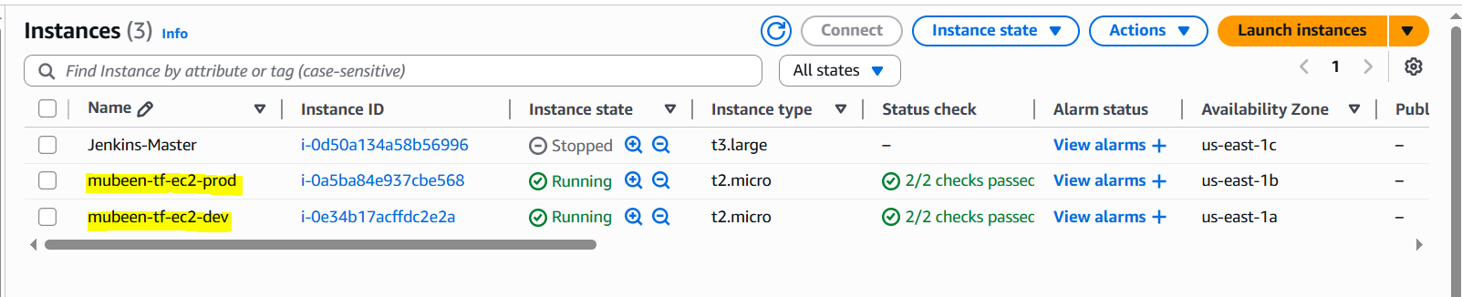

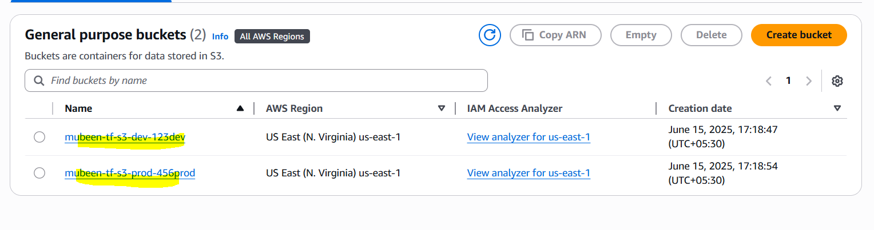

4) Provision ec2 for 3 different environments (Dev, Staging and Prod) using terraform workspaces.

Main.tf:
provider "aws" {
region = "us-east-1"
}

resource "aws_instance" "web" {
ami = lookup(var.ami_map, terraform.workspace, "ami-02f3f602d23f1659d")
instance_type = lookup(var.instance_type_map, terraform.workspace, "t2.micro")

tags = {
Name = "web-${terraform.workspace}"
Env = terraform.workspace
}
}

Varaibles.tf:
variable "ami_map" {
type = map(string)
default = {
dev = "ami-02f3f602d23f1659d"
staging = "ami-08ad56edbda00ef8a"
prod = "ami-0c7217cdde317cfec"
}
}

variable "instance_type_map" {
type = map(string)
default = {
dev = "t2.micro"
staging = "t2.small"
prod = "t2.medium"
}
}

Output.tf:
output "instance_id" {
value = aws_instance.web.id
}

output "public_ip" {
value = aws_instance.web.public_ip
}

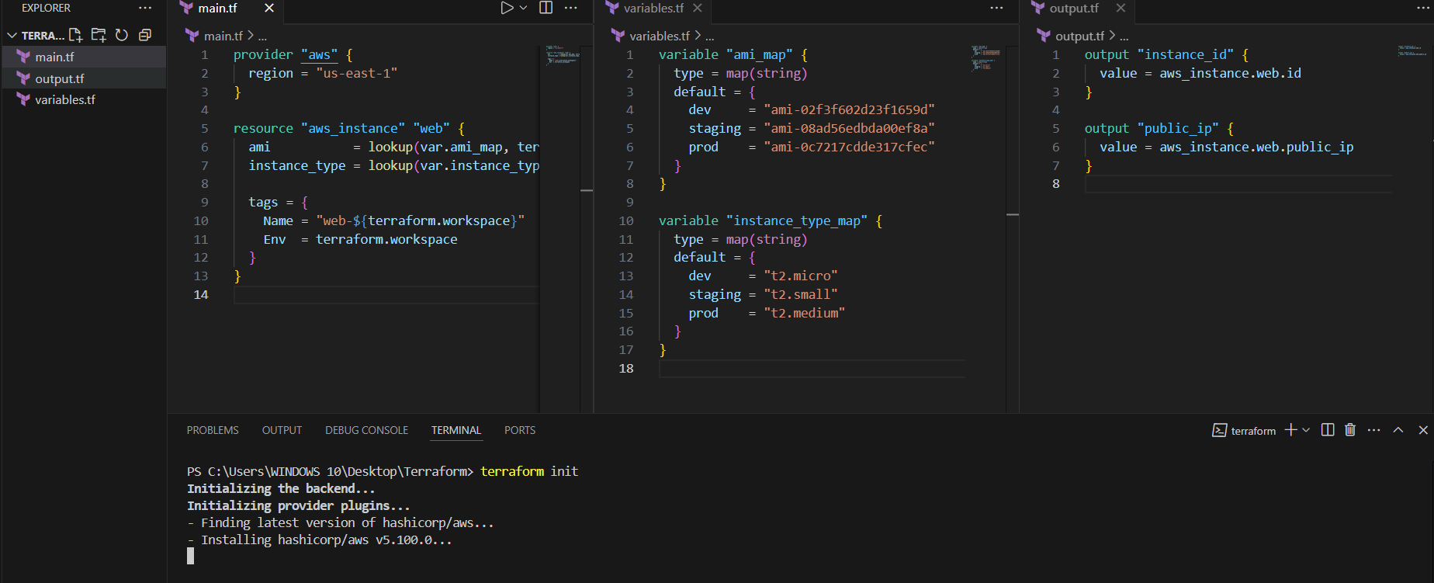

Need to initialise first.

Create three workspaces.
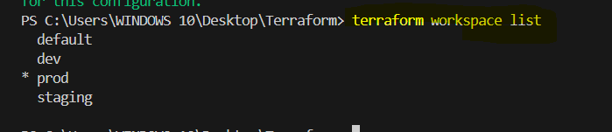

dev workspace:
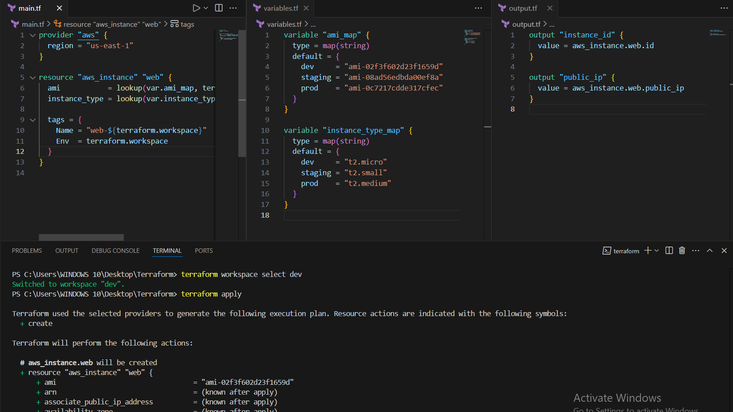
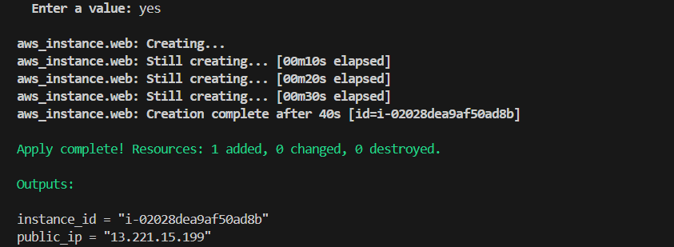

staging workspace:
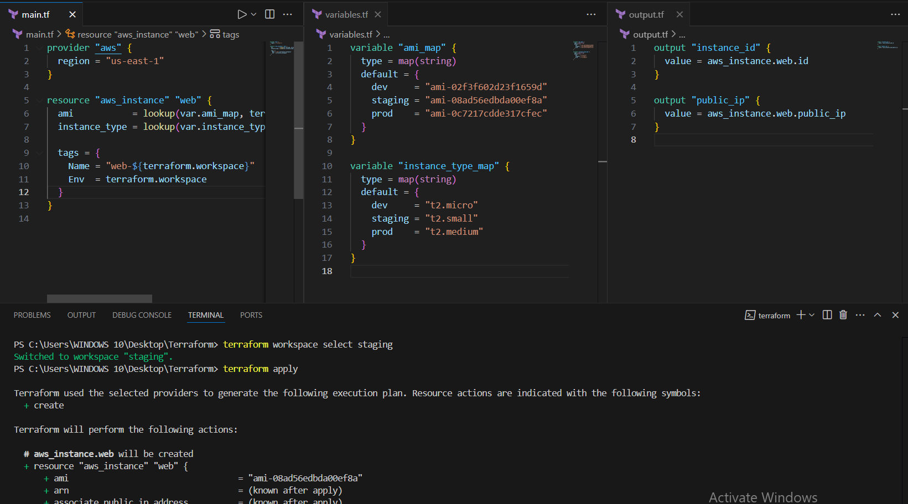

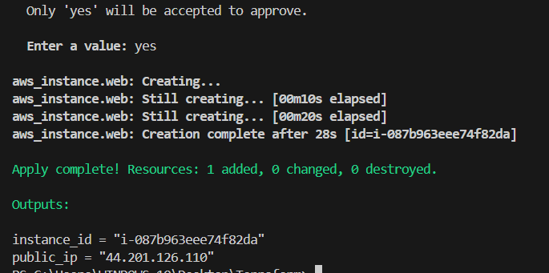
prod workspace:
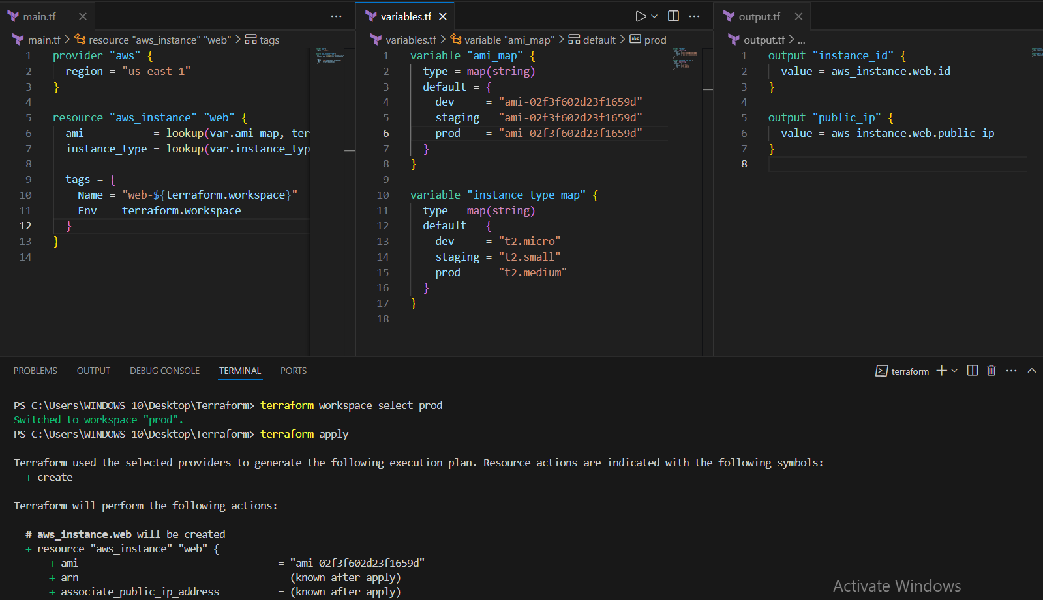

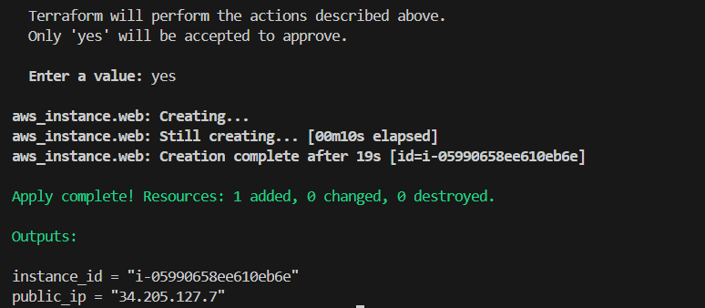

Verifying at console:
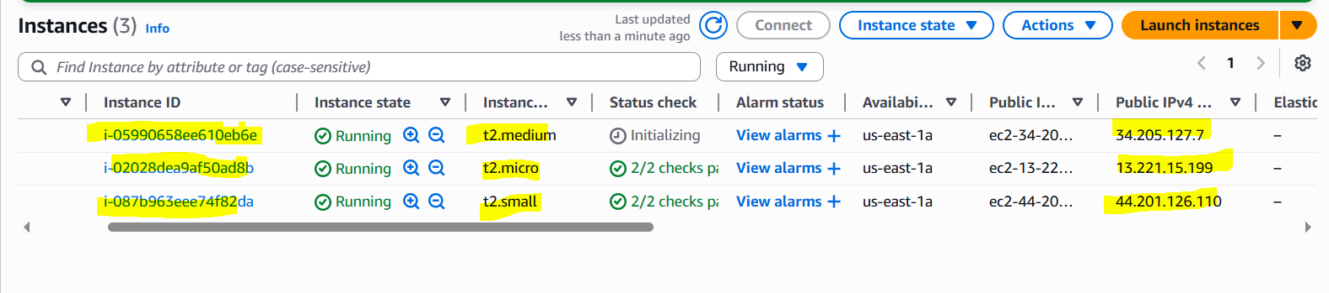
THE-END

